Lab 5 Report:
Minimax working and Alpha Beta pruning: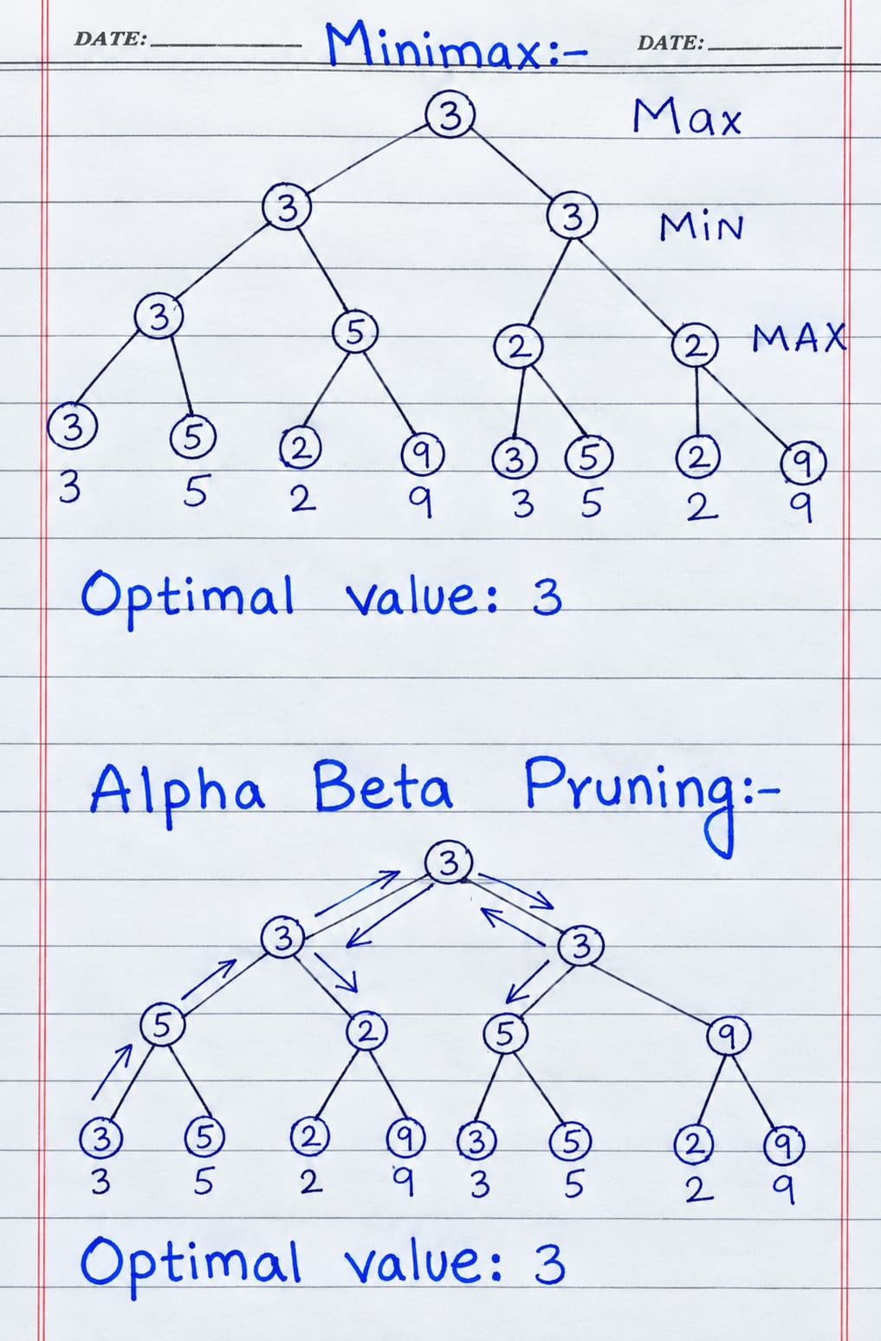
ROOT VALUE:
The root value of both is remain same.

